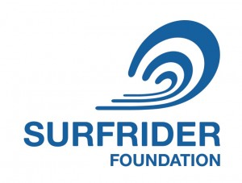
Cocoa Beach Surfrider Foundation Chapter Meeting
Oct 17, 2018 - Café Surfinista, 6pm – Candidates Forum
Special Visitors_______________________
County Commission, District 2 - Bryan A. Lober (REP) / Victoria J. Mitchner (DEM)
City Commission Seat 4 - Tim Tumulty / Skip Williams
City Commission Seat 5- Loi McKinley / Mike Miller
Old Business
- Oct 4 – Indian River Lagoon – “A Day in the Life” – CB High School 8AM
- Oct 6 – “Straws” documentary event – CB Playhouse
- Anything Else?
New Business
- Oct 21 – Outdoor Afro Surf Lessons – School of Surf – 1 PM
- Nov 9-11 – Surfrider State Conference – Deerfield Beach
- Nov 14 – Chapter Meeting (moved from Nov 21 due to Thanksgiving)
- December 8 – CB Christmas Parade
- December 19 – CB Surfrider/Museum Christmas Party
- Membership – 2018 goal is 125. Free t-shirt or rash guard for first time new members.
- Campaigns for CB Surfrider:
  - Pollution – CB Sustainability Committee – working on CB Straw Resolution. Some local businesses have already adopted paper straws and other measures.
  - Coastal Preservation – SOS: Save Our Shoreline – will feature data from our Beach Nourishment Surf Impact Study as well as other sources. Goal is a permanent sand bypass station at the Port Canaveral Jetty to transfer beach compatible sand to the North Reach. Eliminate need for dredge and fill using Canaveral Shoals. See our website or Facebook for details.
  - Dune Protection – need candidates for 2019 planting
  - New CBSR Cups are here
  - New CBSR stickers?
  - Officer Election in November – Treasurer, Volunteer Coordinator, Event Coordinator, Secretary - Social Media
  - Anything Else?
Lawrence’s Last Word

