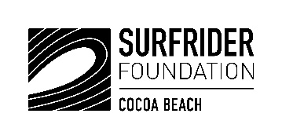
Cocoa Beach Surfrider Foundation Chapter Meeting Agenda
March 20, 2019 - Café Surfinista, 6pm
Special Visitors______________
- Dave Miller – “Who Will Save Atlantis?”
Old Business
- Feb 20 – New EC Members:
  - Angela Tilger – Social Media
  - Eric Schmidt – Volunteer Coordinator
- Anything Else?
New Business
- New Life Preserver Stations on Beach – in dunes
- Mar 23 – TEDx Talks – Surfside Playhouse, 1 PM
- Apr 5 & 6 – Honey Miller Surfrider Benefit Concert at Surfside Playhouse
- Apr 6 – Lagoon Trash Bash, Lutheran Church on Minutemen Cswy, 8 AM
- Apr 17 – Chapter meeting
- May 18 – Hands Across the Sand – Paradise Park, 11 AM, party after
- Membership – Goal is 125. Free t-shirt or rash guard for first time new members.
- Campaigns for CB Surfrider:
  - Pollution – CB Sustainability Committee – working on CB Straw Resolution. Some local businesses have already adopted paper straws and other measures.
  - Coastal Preservation – Stop Beach Nourishment – will feature data from our Beach Nourishment Surf Impact Study as well as other sources. Goal is a permanent sand bypass station at the Port Canaveral Jetty to transfer beach compatible sand to the North Reach. Eliminate need for dredge and fill using Canaveral Shoals. See our website or Facebook for details.
  - Anything Else?

Lawrence’s Last Word

